**Types of Portugese Red Wines**

“Vinho verde”:

* Sousão – type of Portugese grape used for vinho verde; high quality, high saturation, medium acidity
* Arinto – high quality Portugese wine with high acidity
* Azal Tinto – high quality wine with high acidity
* Alvarinho – light, low-alcohol, slightly spritzy wine from northwest Portugal; medium quality, affordable

*Acidity is actually a positive quality – sharp acidity pairs well with the rustic, bean, and oily codfish dishes endemic to Portugal[1]

*High acidity was also a historical necessity – (farmland in weird spot)

*Saturation is based on the bottling…



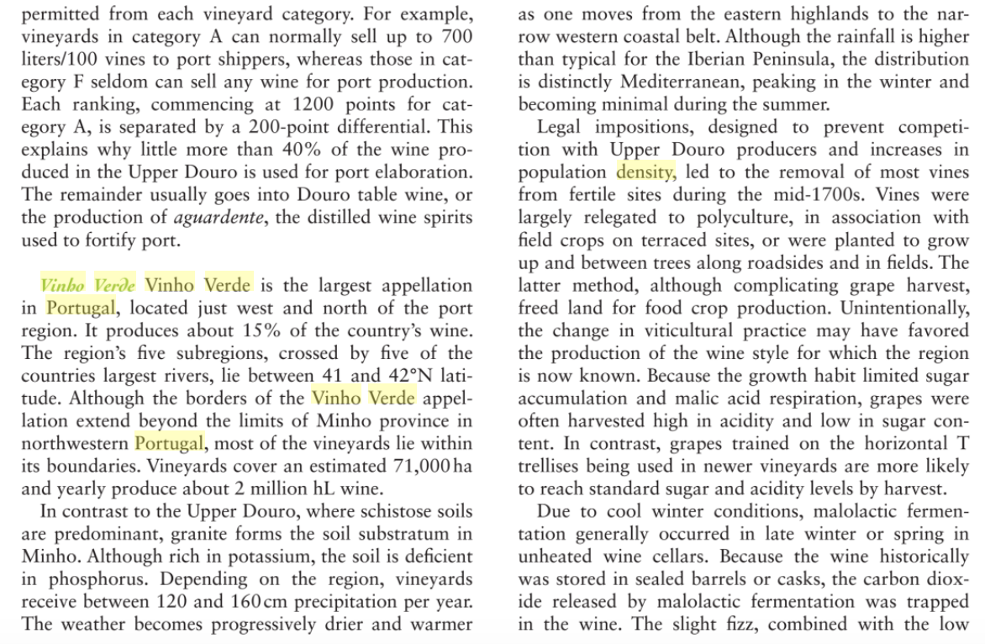



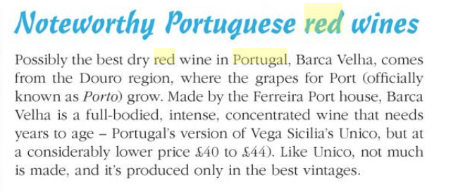

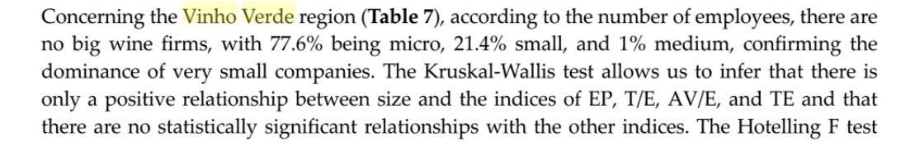

1. Karen McNeill, *The Wine Bible*. (2015).